Chapter 1

1. Socket is the combination of ip an port.
2. Osi stands for open system intercommunication.
3. The length of ipv4 ipv4 is 32 bits s 0(2 ^32 address) and ipv6 is 128.
4. The mac address is 6 bytes/48bits long.
5. ARP stands fot Adress resolution protocol and is used to convert an ip into its coresspondint mac address.

Chapter 3

1. In mesh topology devices is connected to each other via particular channel.
2. In star topology all the devices are connected to single hub.
3. In bus every device is connected to a single cable. (no-biderirection)
4. In ring it forms ring like structure with two neighbouring devices (both uni and bidirectional)
5. Tree topogy a central hub I connected with secondary hubs.

Chpater4

1. LAN covers small geographical area prob few kms.
2. MAN is collection of LAN.
3. WAN is the internet.

There are other types of Computer Networks also, like :

PAN (Personal Area Network)

SAN (Storage Area Network)

EPN (Enterprise Private Network)

VPN (Virtual Private Network)

Chapter 5

1. OSI was developed by International organization for standardization in 1984.
2. It has 7 layer (physical, datalink , network)hardware, transport(heart) , session, presentation and application.(software).

Physical layer

It is responsible for actual physical connection.

The physical layer contains information in form of bits.

Functions are:

Bits shyncronization.

Bit rate control.

Transmission mode.

Physical topologies.

Devices used here are:

Data link

Responsible for node to node or host to host communication .

Main function is to make sure data transfer is eroor free.

It is divided in two layers

Logical link control

Media access contro

In this layer packet received from network layer is further divided in frames depending on the size of NIC.

Main functions are ;

Framing

Physica addressing

Flow control

Access control

Network layer

Sender to reciver communication

Takes care of packet routing ie selection of shortest part for packet transfer,

The main functions are

Routing

Logical address mean IP

Transport layer

The data here is call segments

At senders side:

This layer recives data performs segmentation and also implements flow and control error

At receivers side:

The layer reads port number form its header and forward data to specified one.

Functions are:

Segmentationa dn reassembly

Service point addressing.

Session layer

Responsible for establishment of connection

Function

Syncrhonzation which helps to identify error

Session establish, maintenance, termination

Dialog controller

Presnetation layer:

Main functiona are

Translation from ASII to EBCDIC

Encryption/ decryption

Compression

Aplication layer:

The top layer Function are:

1. Network Virtual Terminal
2. FTAM-File transfer access and management
3. Mail Services
4. Directory Services

OSI Model as a reference model and is not implemented on the Internet because of its late invention. The current model being used is the TCP/IP model.

Chapter 6:

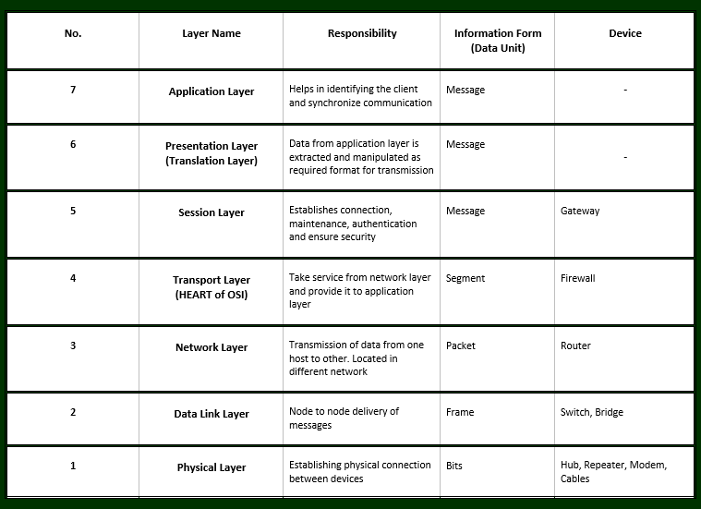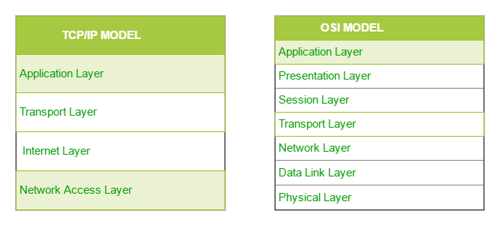

Chapter 7

*Ethernet frame format*

Basic frame format which is required for all MAC implementation is defined in **IEEE 802.3 standard.**

PREABMLE: this is pattern of 0’s and 1’s which helps in bit synchronization

SFD: It hleps to warns station about synrchonization.

Destionation mac

Source mac

Length

Data- The data is also called payload.

Cyclic redundancy Check (CRC): is a 4 bit field. It contains hash code of data. It is generated over Destination address , source add, length and data. If checksum computed by destination is not same as sent data then data is corrupted.

The size of frames is from 64 to 1518 total nai vaneko.